Evolution of Software Development

**Traditional Waterfall Model:**

* Complete req are clear and fixed
* Prod def is stable

**Agile Development model:**

* Req change freq
* Development needs to be fast

**DevOps approach**

* Req change freq
* Dev needs to be Agile
* Operations need to be agile

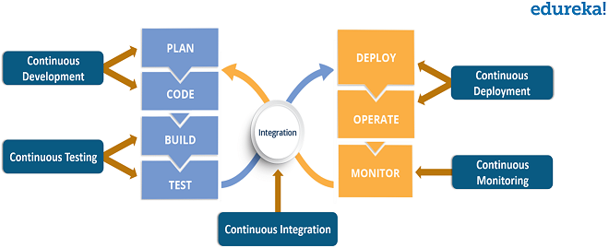 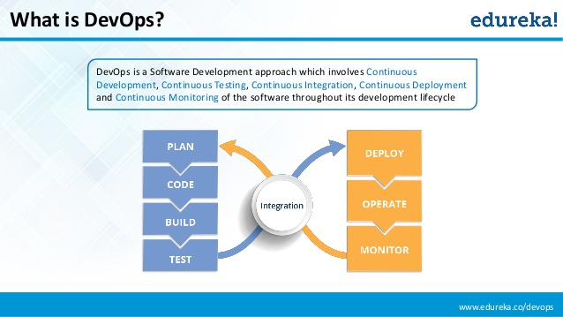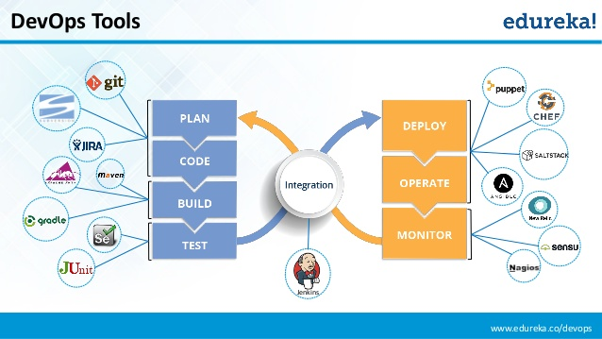 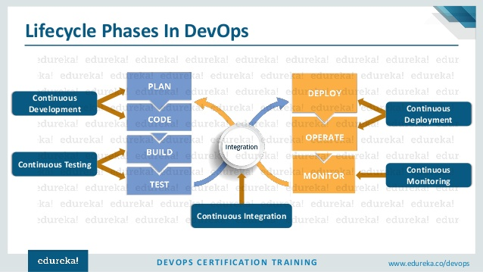

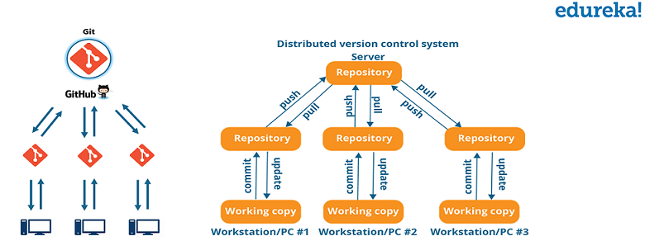 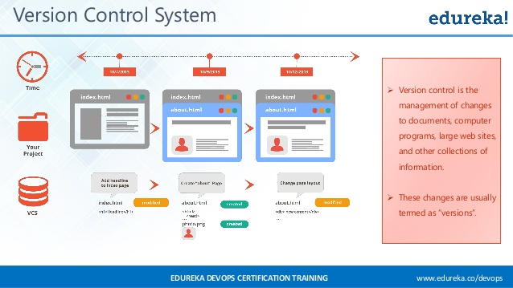

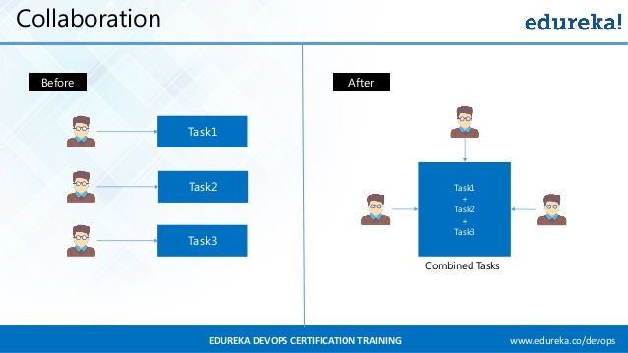

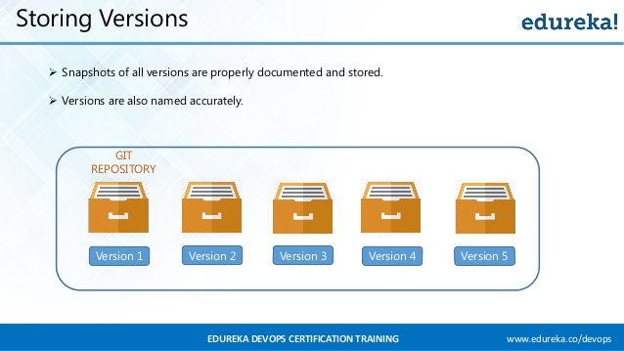 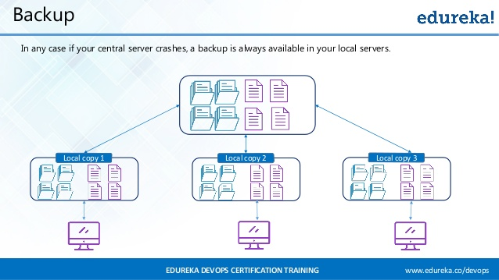

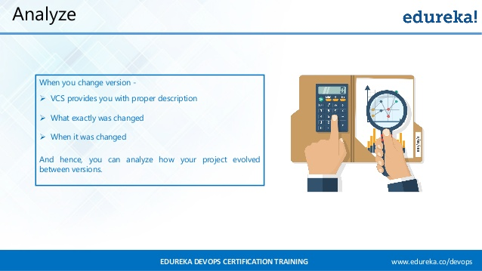

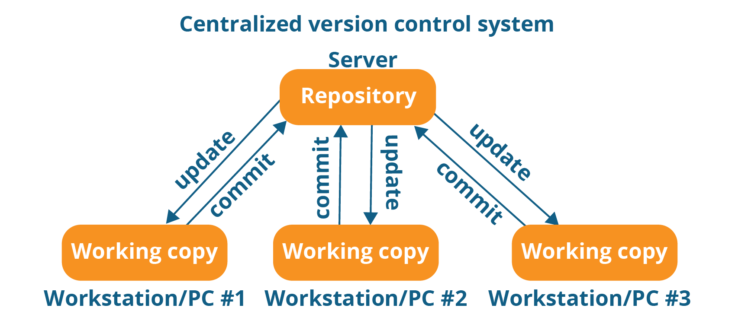

CVCS

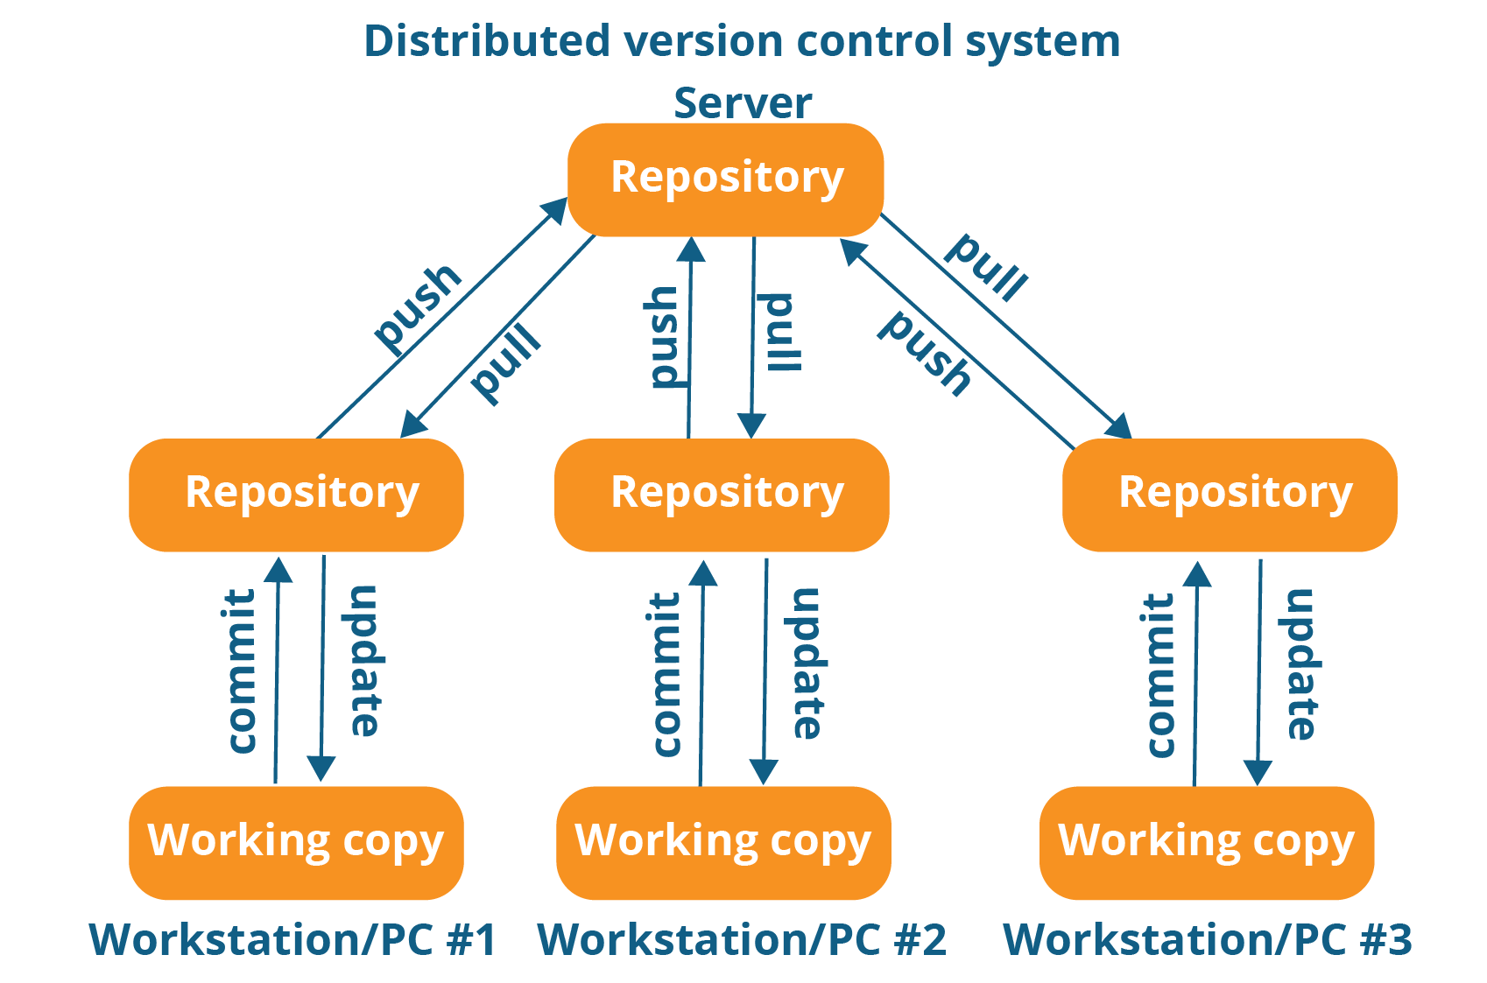

DVCS

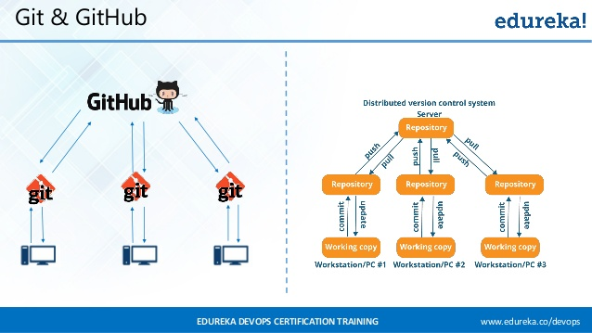

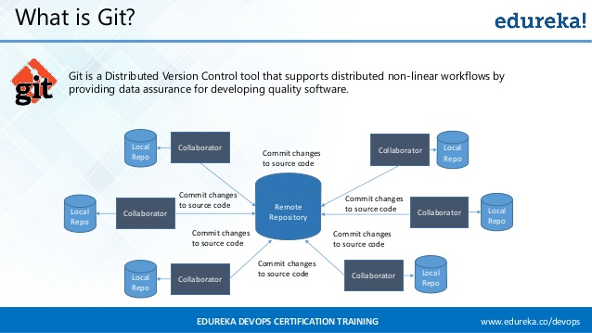

Git commands

**git --version**

**git help**

**git init** --> to create a local repository

**git status** --> to check the status

**git config --global user.email "mail-id"** --> to set the username

**git add filename.ext** --> to add a file

**git add foldername/** --> to add a folder

**git commit -m "Add a file"** --> to commit

**git log** --> gives the commit history

**git log --name-status --since**="2 days ago" --> to get log history for the past 2 days

**git remote add <alias name for the url> <url of the repository>**

( ex:

**git remote add origin https://github.com/DIVYALAKSHMI13298/HCL-Demo.git**  )

**git push origin master**

**git pull origin master**

DAY 2

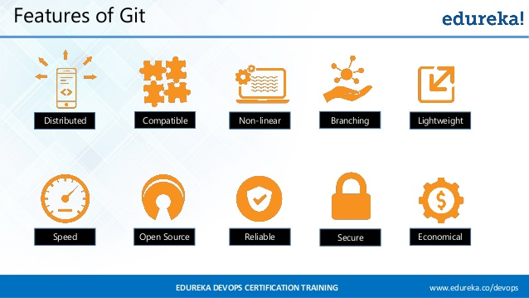

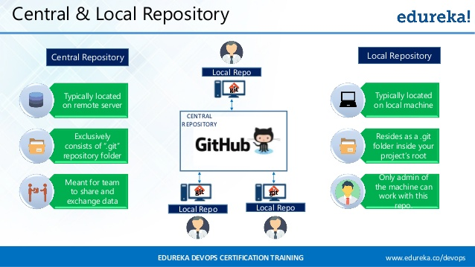 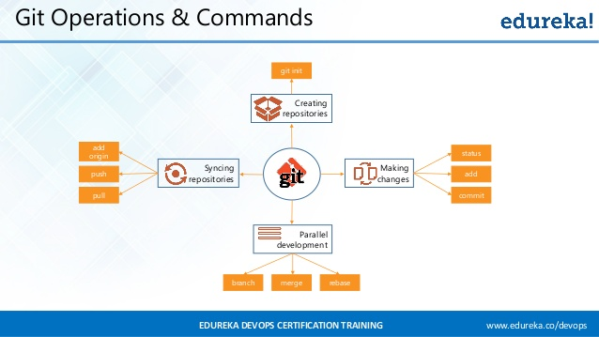

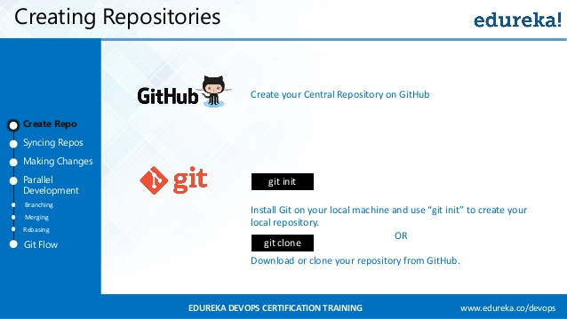

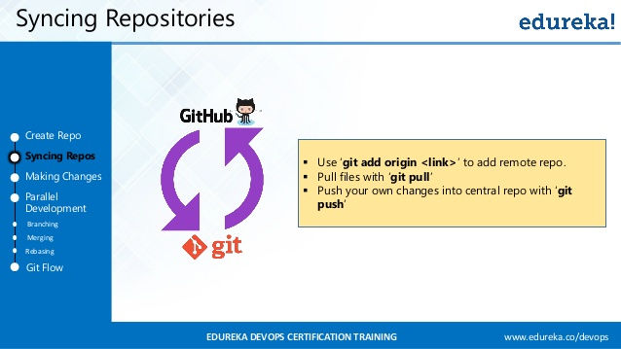 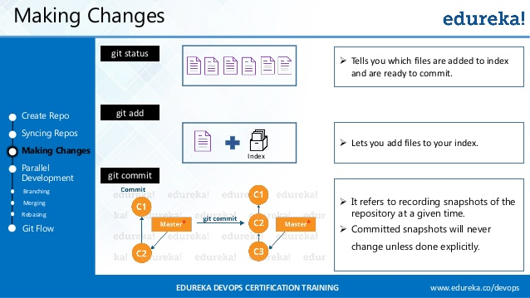

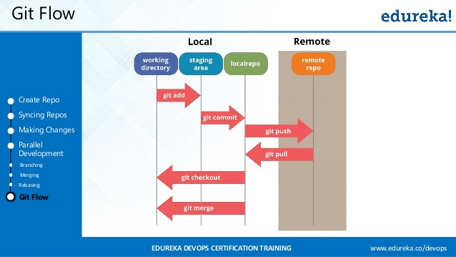

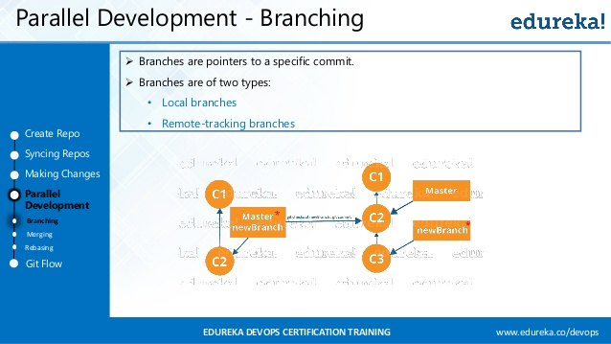 parallel development branching(contd)

how to create branch in git and gitHub

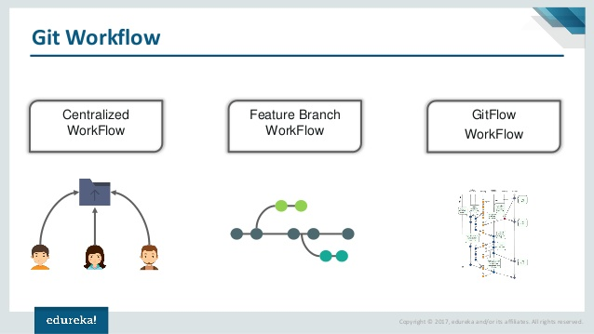

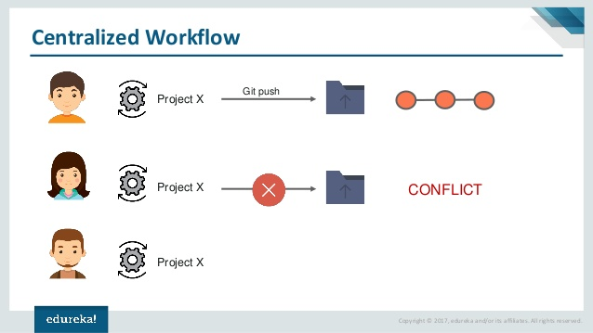

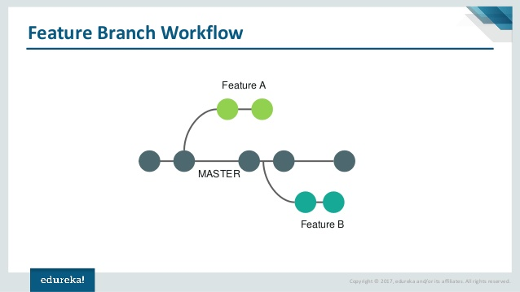 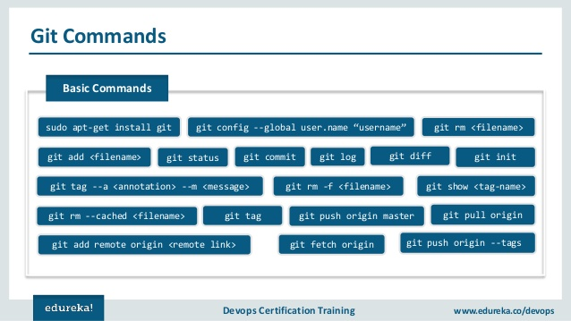

Git commands

git branch branchname --> to create a branch

( ex: git branch develop)

git checkout branchname

( ex: git checkout master, git checkout branchname)

git merge branchname

( ex: git merge develop)

git pull origin master

git push origin master

Day 3

continuous integration

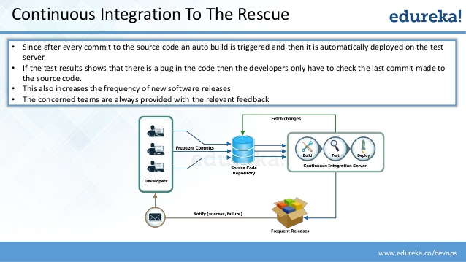

benefits of CI

**SonarQube**

C:\HCL_Java\sonarqube-7.4\bin\windows-x86-64>StartSonar.bat

**To run where pom.xml is located**

C:\Divya\New folder\HospitalManagementSystem>mvn clean install

**To import a project into sonar**

C:\Divya\New folder\HospitalManagementSystem>mvn sonar:sonar -Dsonar.host.url=ht

tp://localhost:9000 -Dsonar.login=admin -Dsonar.password=admin